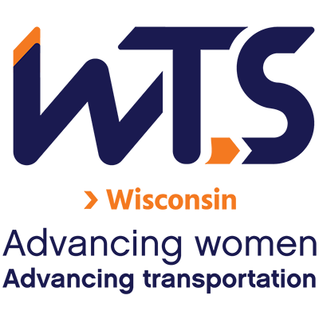

WTS Transportation YOU High School Scholarship

WTS fosters the development of women and girls in the transportation field by encouraging bright new professionals and students to undertake careers in the area of transportation. One way it does this is by awarding the WTS Transportation YOU High School Scholarship to girls pursuing high school studies in science, technology, engineering, and math.

Transportation YOU is a hands-on, interactive, mentoring program that offers young girls ages 13-18 an introduction to a wide variety of transportation careers. Through the Transportation YOU program and this scholarship, WTS chapters work to make a difference in the lives of young girls by offering opportunities and activities that will spark their interest in all modes of transportation and encourage them to take courses in math, science, and technology, which are the stepping stones to exciting careers that can change the face of the transportation industry.

The WTS Wisconsin Chapter will provide up to two Transportation YOU High School Scholarships in the amount of $1,000-$2,000. One winner will become eligible for the national scholarship of $2,500. The minimum criteria for selection are:

- Applicant must be a high school senior.
- GPA of 3.0 or higher.
- Currently studying math, science, and technology.
- Considering a college degree in a transportation-related field
- Resides in, works in, or attends school in the state of Wisconsin.
- Has not previously been a winner of the Transportation YOU Scholarship through WTS Wisconsin.

Applications must be submitted through local WTS chapters as typed documents. Scholarships are competitive and based on the applicant's specific transportation goals, academic record, and transportation-related activities or job skills. WTS-Wisconsin award winners will be announced mid-December 2026 and will be celebrated at the WTS-Wisconsin awards event in Spring 2027. National awards will be presented during the WTS Annual Conference in May 2027, and attendance during the awards ceremony is strongly recommended. Conference registration for scholarship winners is complimentary. Local chapters will assist with arrangements upon selection and may have additional requirements, such as personal interviews or higher GPA.

Please send your questions and application to wts.wisconsin@gmail.com

Submissions will be accepted until 11:59 p.m. on Sunday November 29, 2026.

WTS Transportation YOU High School Scholarship Application

I. Personal Information

Last Name | First Name | Middle
Email Address |  | Phone Number
Street Address, City, State,

Educational Background

Current High School

City, State

Expected Date of Graduation | Current Grade Point Average  (Minimum 3.0. Attach official copy of transcript to application.)
Area of Concentration

Professional or School Affiliations (List any school, professional or community activities you have participated in. Include offices held and awards received.)

III. Recommendation: Letter of recommendation by a teacher, counselor, or principal must accompany your application.
X Provided

IV. Personal Statement:

Applicant Signature |  | Date

Parent/Guardian Signature |  | Date

V. Demographic Information: WTS is committed to recognizing the achievements of students pursuing transportation related degrees. To track our progress in reaching diverse applicants, we ask that you complete this confidential demographic information. This is not required for scholarship awards and will not be used in the selection process.

- Race/Ethnicity (select all that apply)
☐ Asian
☐ Black
☐ East Indian
☐ Hispanic/Latino
☐ Indigenous
☐ Middle Eastern
☐ Multiracial
☐ Pacific Islander
☐ White
☐ Other (Please write in):
☐ Choose Not to Disclose
- Age
☐ 15-18
☐ 19-23
☐ 24-30
☐ 31-50
☐ 50 +
- Anticipated or Current Mode of Transportation Career Focus (select all that apply)
☐ Aviation
☐ Freight
☐ Highway/Auto
☐ Maritime/Port
☐ Multi-Modal
☐ Non-Motorized
☐ Passenger
☐ Transit
☐ Other (Please write in):
- How did you hear about this scholarship?
☐ Friend
☐ School/Teacher
☐ WTS Chapter
☐ WTS International Website
☐ Other (Please write in):
☐ Social Media:
☐ Facebook ☐ Instagram
☐ LinkedIn ☐ Snapchat
☐ TikTok ☐ Twitter
☐ YouTube ☐ Other (Please write in)
- Are you currently a WTS Member?
☐ Yes
☐ No

